DCSmallBizLoans.com
Get the capital you need for your small business!

Small businesses sometimes don’t meet the credit and other financial requirements of traditional financial institutions. DCSmallBizLoans.com gives you access to four local community lenders at the same time.
How can I apply for a loan? With a single registration on DCSmallBizLoans.com, a business can prequalify for a selected loan product. After an initial matching process, the borrower then completes and submits the loan application(s) online.
Getting started is as easy as 1-2-3
Participating community lenders
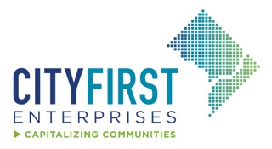
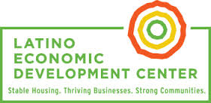
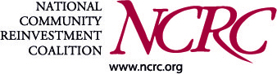
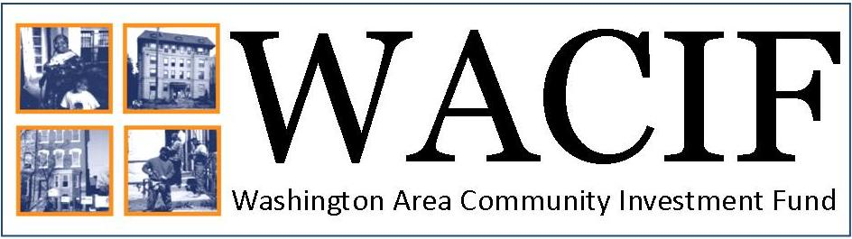
Step 1. Register or sign up to create your business profile at DCSmallBizLoans.com
Step 2. Start the online application
- Business and personal information
- Tell us your financing needs
Step 3. Upload your supporting documentation
- Copy of driver’s license or photo ID
- Up to 2 years of business and personal tax returns
- 3 months business and personal bank statements
- Additional information may be required, depending on the type of loan
How much capital can I apply for? There are no hidden fees – and applicants can apply for working capital loans of $5,000 - $200,000 and real estate loans of up to $1 million in just minutes.
How safe is my information? DCSmallBizLoans.com was developed by Biz2Credit and tailored for the needs of District businesses and community lenders. Biz2Credit has arranged more than $1.2 billion in small business financing by matching borrowers to financial institutions based on each company's unique profile. All information is protected on the secure site.
I completed my online application, Now What? A community lender will contact you to follow-up with you personally.
Participating Lenders:
City First Enterprises (CFE): Since 1993, City First Enterprises has worked to promote social justice by increasing economic access and expanding opportunity for low-wealth communities. Located in Washington, DC, City First Enterprises is a nonprofit bank holding company and an incubator of social finance solutions that promotes social justice by increasing economic access and expanding opportunity for low-wealth communities. CFE has launched City First Bank, City First Homes and City First New Markets Tax Credit Venture Fund. In total, the City First family has financed over 5,000 units of affordable housing, 7,000 school seats, and 3,400 jobs. City First Enterprises is a proud to be supported by a White House Social Innovation Fund. Visit http://cfenterprises.org and follow us on Twitter @CityFirstEnterp.

Latino Economic Development Center (LEDC) equips Latinos and other underserved communities in the D.C. and Baltimore Metropolitan Areas with the skills and tools to achieve financial independence and become leaders in their communities. LEDC's Micro-Lending Program equips entrepreneurs in the DC-region with the capital to improve their lives and strengthen the small business community. LEDC's Micro-Lending Program provides business loans between $5,000 and $50,000 to qualified start-ups and existing businesses that have difficulty obtaining credit from mainstream financial institutions. These loans have supported a broad range of small business owners, including restaurants and boutique shops to cleaning and catering companies. Since 1997, the Lending program has provided more than $6 million of capital to support entrepreneurs in the DC-region. Visit http://www.ledcmetro.org, follow us on Twitter @ledcmetro.

National Community Reinvestment Coalition Community Development Fund
(NCRC CDF) is an emerging community development loan fund established as an independent affiliate of the National Community Reinvestment Coalition (NCRC). NCRC CDF is a ‘triple bottom line’ CDFI that measures the success of its investments by financial return, positive social impact, and environmental benefits to the communities served. NCRC CDF helps small businesses and emerging entrepreneurs grow and thrive by lending to historically underrepresented business owners and by pairing our loans with expert consulting services and technical assistance. Visit http://www.ncrc.org and follow us on Twitter @NCRC.

Washington Area Community Investment Fund (WACIF) is a nonprofit community development loan fund whose mission is to empower underserved communities and individuals in the Washington, DC metropolitan area by providing access to capital and technical assistance to small businesses, childcare centers, affordable housing developers, and community organizations. Since inception, WACIF has closed over 315 loans totaling $24.6 million, helping leverage over $150 million in financing for local low- and moderate-income entrepreneurs and nonprofit organizations. WACIF has assisted over 1,750 small businesses through one-on-one assistance, provided $55 million in access to capital in lending, and created more than 1,400 full- and part-time jobs. Visit http://wacif.org, follow us on Twitter @WACIF.
DCSmallBizLoans.com Brought to you by: The DC Small Business Policy Project (SBPP),
co-convened by the Coalition for Nonprofit Housing and Economic Development (CNHED) in partnership with the DC Department of Small and Local Business Development (DSLBD) One of our goals is to make it easier for entrepreneurs to access the capital they need to launch and grow successful businesses. Funding for the SBPP is generously provided by Citi Community Development. Visit http://www.cnhed.org/smallbusiness/

